Description
Report Item


ESP32-S3-Touch-LCD-3.5B
Integrated Audio Input And Output, Enabling AI Interaction And Offline Voice Control

IMPORTANT: the version 3.5 and 3.5B are QUITE different!!

https://www.waveshare.com/wiki/ESP32-S3-Touch-LCD-3.5B
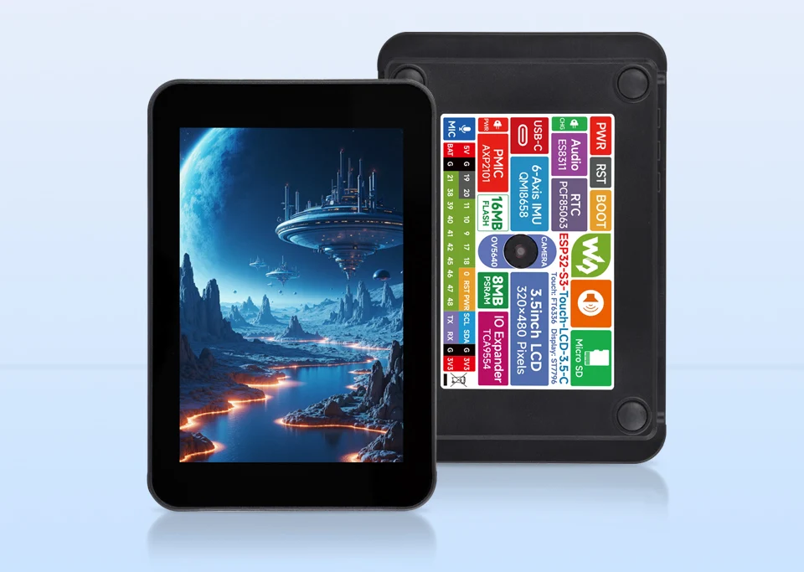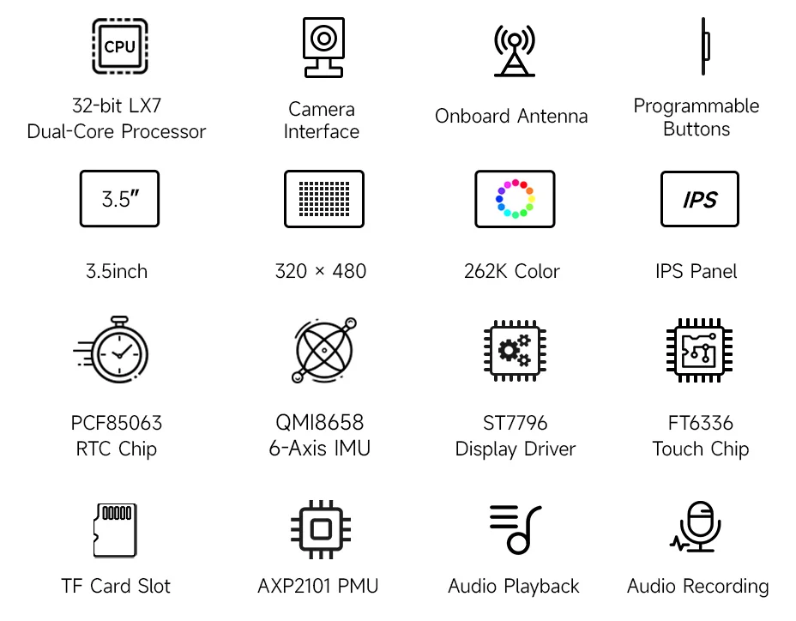

Version Options
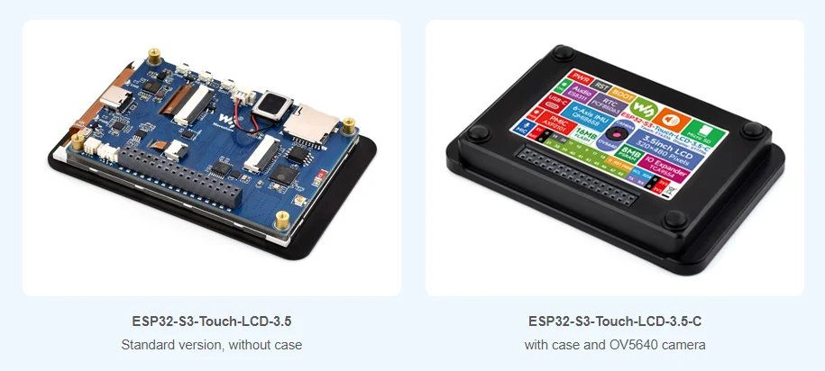
Features
ESP32-S3-Touch-LCD-3.5 is a high-performance, highly integrated MCU board designed by Waveshare. Onboard 3.5inch capacitive touch IPS display, power management IC, 6-axis sensor (3-axis accelerometer and 3-axis gyroscope), RTC, low power audio codec, and so on, which makes it easy for you to develop and integrate into the products quickly.
Key features include:
- Equipped with ESP32-S3R8 Xtensa 32-bit LX7 dual-core processor, up to 240MHz main frequency
- Supports 2.4GHz Wi-Fi (802.11 b/g/n) and Bluetooth 5 (LE), with onboard antenna
- Built in 512KB of SRAM and 384KB ROM, with onboard 8MB PSRAM and an external 16MB Flash memory
- Type-C connector, improving device compatibility, easier to use
- Onboard 3.5inch capacitive touch display for clear color picture display, 320 × 480 resolution, 262K color
- Built-in ST7796 display driver and FT6336 capacitive touch chip, using SPI and I2C communication respectively, effectively saving the IO resources
- Onboard QMI8658 6-axis IMU (3-axis accelerometer and 3-axis gyroscope) for detecting motion gestures, counting steps, etc.
- Onboard PCF85063 RTC chip, powered by main Lithium battery through AXP2101 chip, with reserved RTC battery header for connecting a backup battery, ensuring RTC function during the replacement of the main battery
- Onboard PWR and BOOT programmable buttons for easy custom function development
- Onboard 3.7V MX1.25 Lithium battery recharge/discharge header
- Adapting I2C, UART, USB, and multiple GPIO pins, for connecting peripherals and debugging
- Onboard TF card slot for extended storage and fast data transfer, suitable for applications such as data recording and media playback, simplifying circuit design
- Onboard camera interface, compatible with mainstream cameras such as OV2640 and OV5640
- Adopts AXP2101 IC for efficient power management, supports multiple voltage outputs, battery charging, battery management, and battery life optimization, etc.

Supports AI Speech Interaction

Allows Access To Online Large Model Platforms Such As DeepSeek, Doubao, Etc.
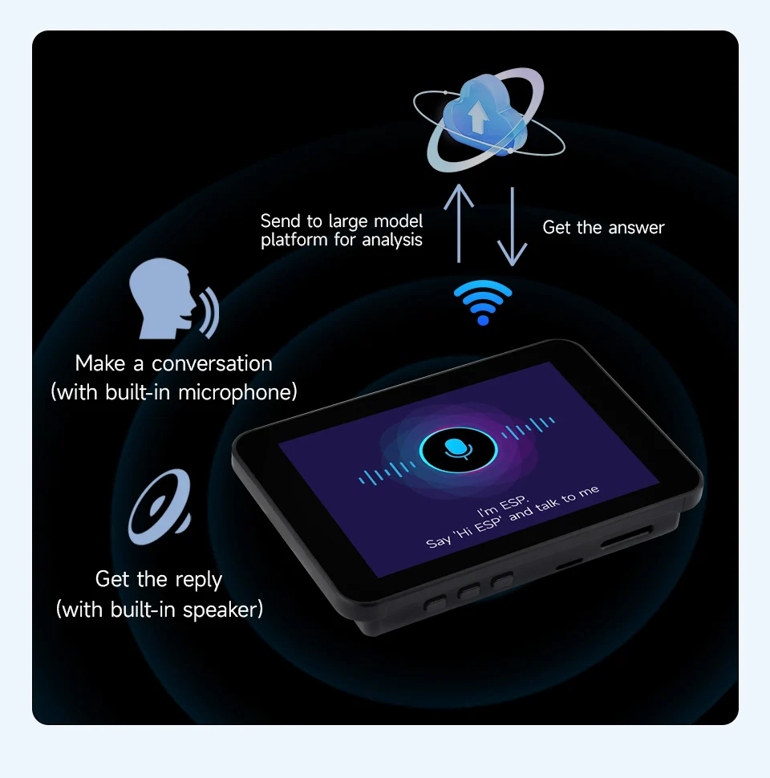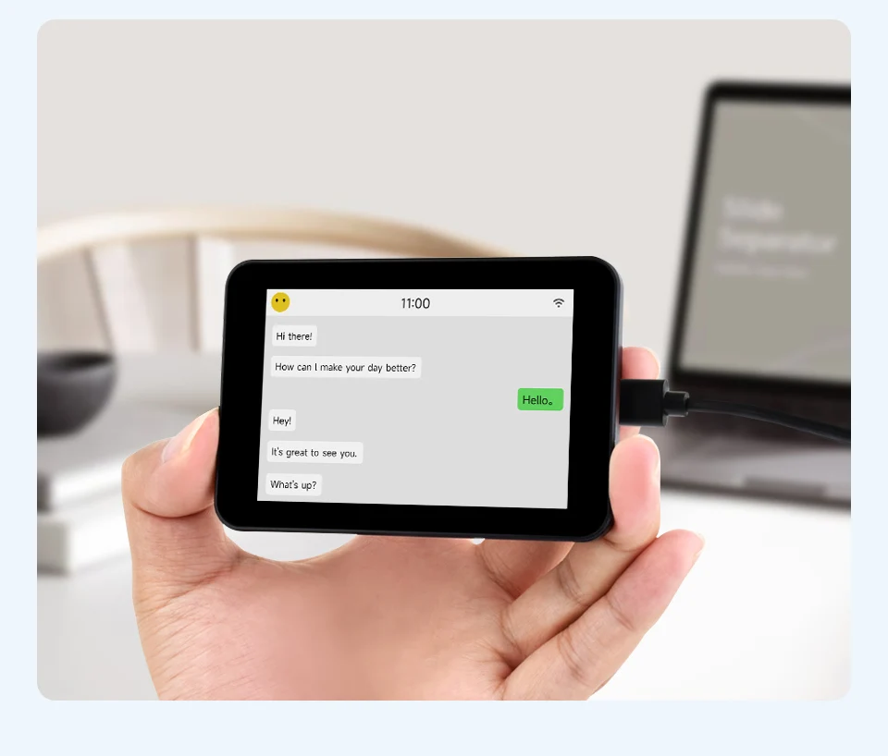

Capacitive Touch

Suitable For Various Smart Device Development, Enabling Human-Machine Interaction
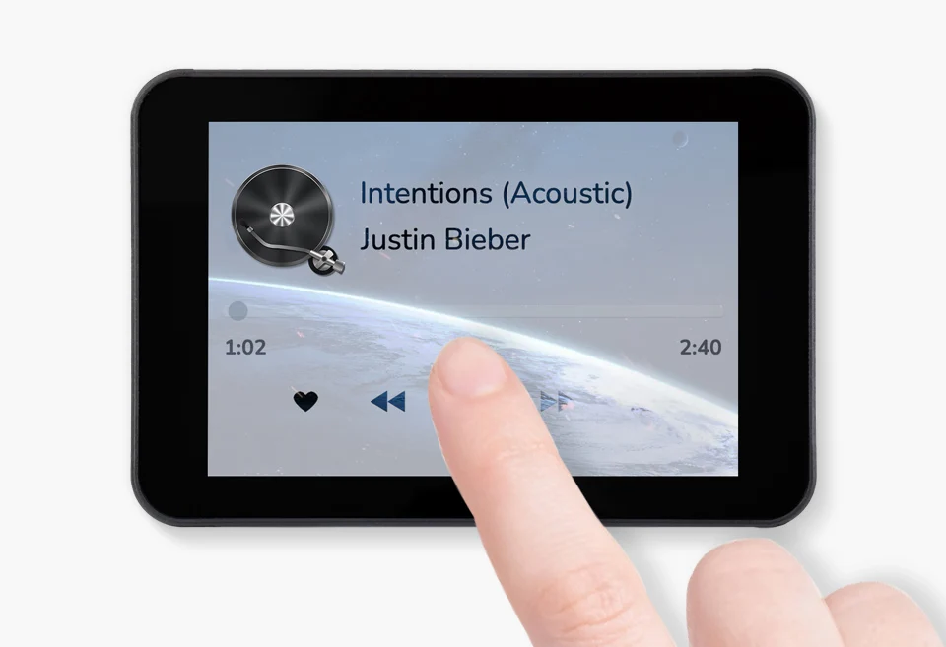
IPS Display Panel

Excellent Display Performance, 262K Color, Wide Viewing Angle
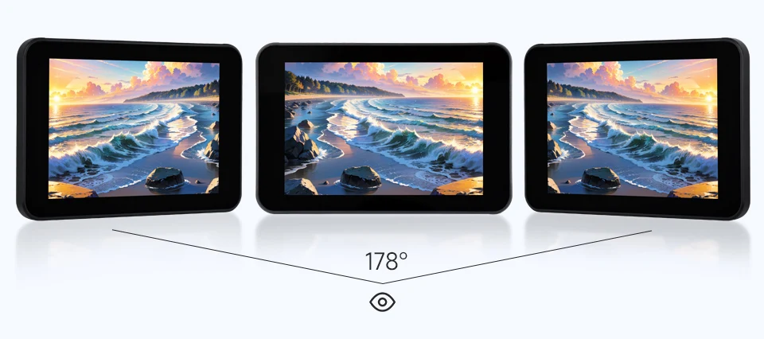
Onboard Audio Codec

Supports High-Quality Audio Processing, Providing Clear And High-Quality Audio Input And Output
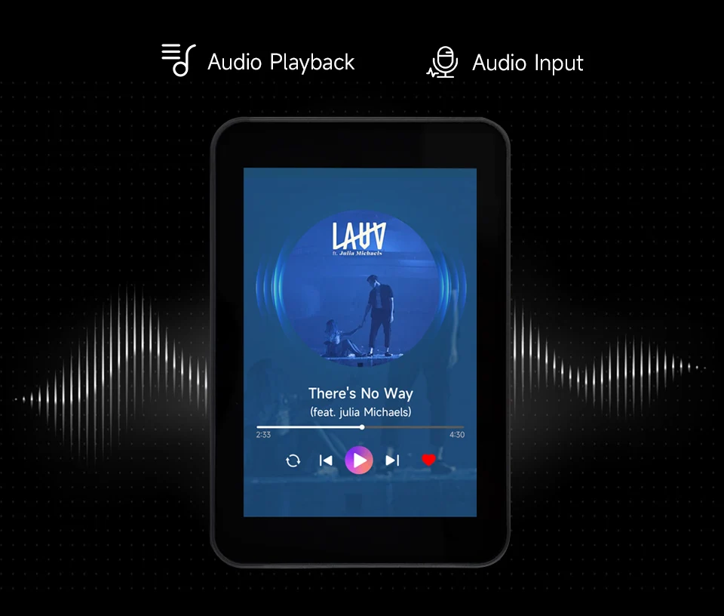
Supports OV2640 / 0V5640 And Other Mainstream Cameras
Optional For OV5640 5MP Camera Module, Suitable For Image Capture, Video Monitoring And Other Applications To Meet Different Needs
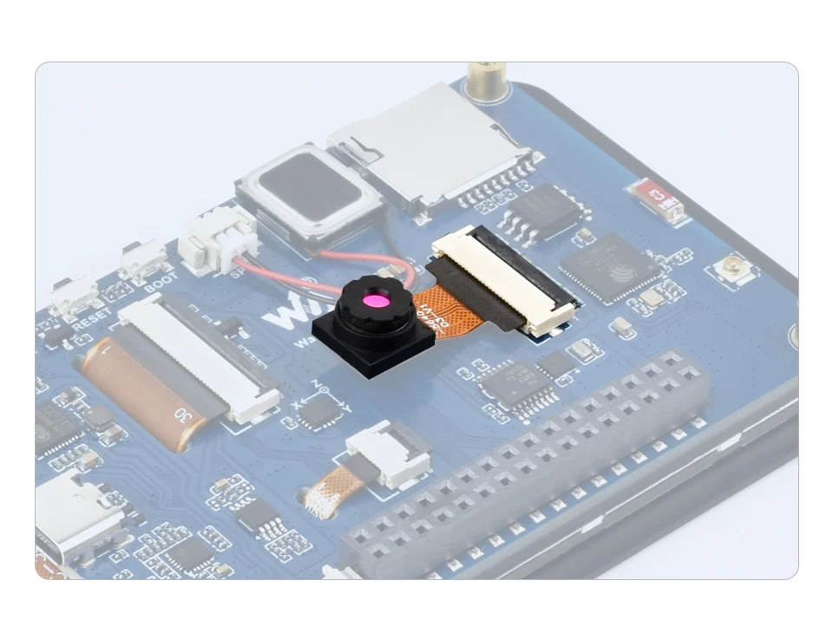
* The OV5640 5MP camera module is only included in the ESP32-S3-Touch-LCD-3.5-C version.

Supports ESP-IDF, Arduino IDE

Comprehensive SDK, Dev Resources, Tutorials To Help You Easily Get Started
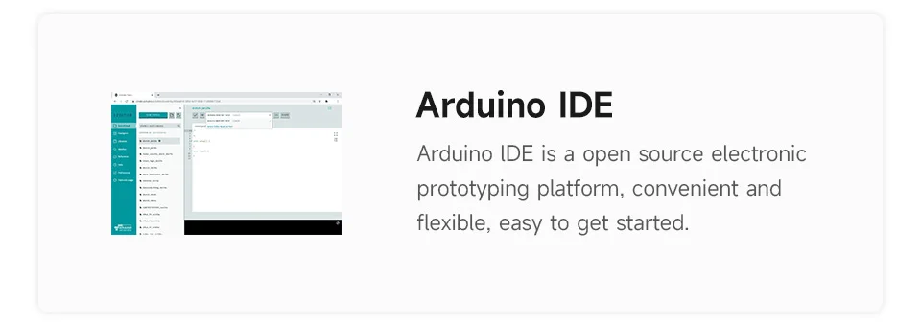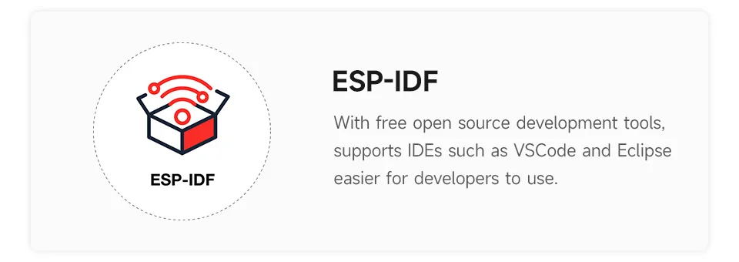

Wi-Fi And BLE 5 Support

ESP32-S3 Integrates 2.4 GHz Wi-Fi (802.11 Ax/B/G/N) With 40 MHz Of Bandwidth Support, Its Bluetooth Low Energy Subsystem Supports Bluetooth 5 (LE) And Bluetooth Mesh
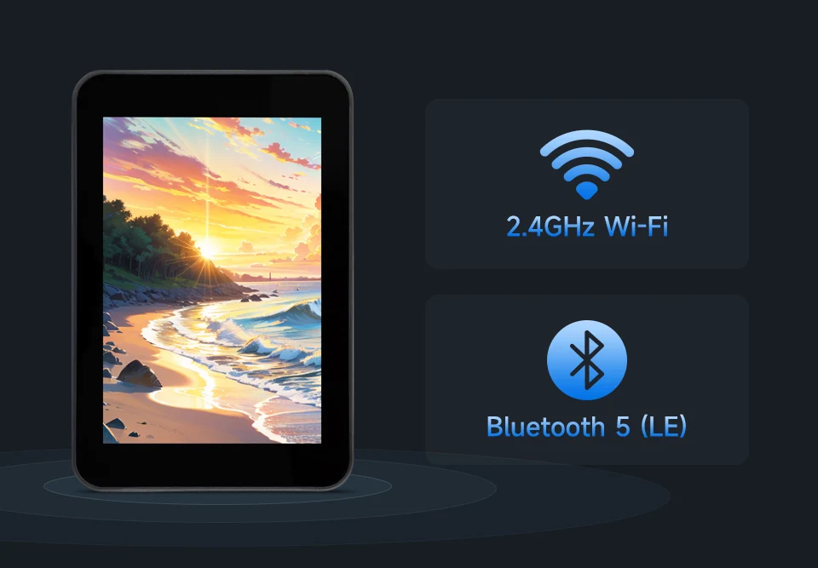

What's On Board
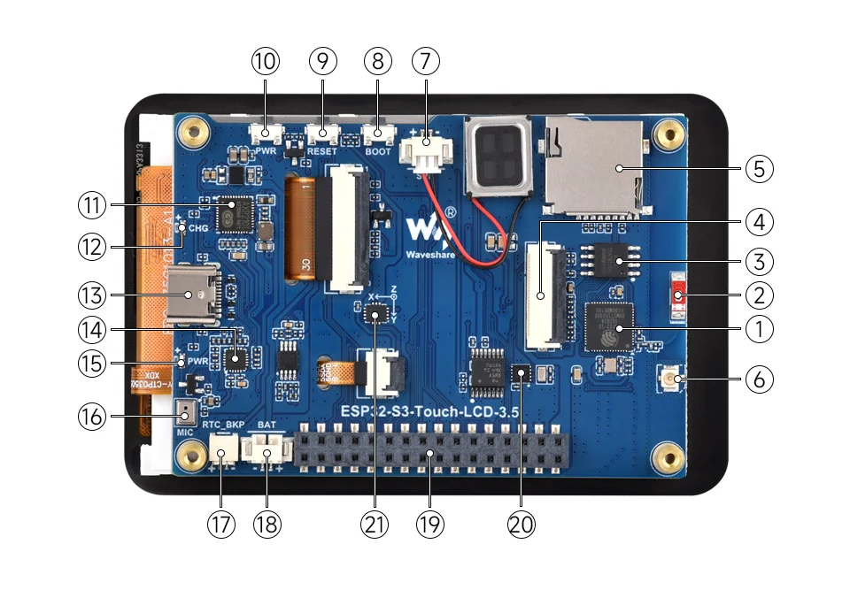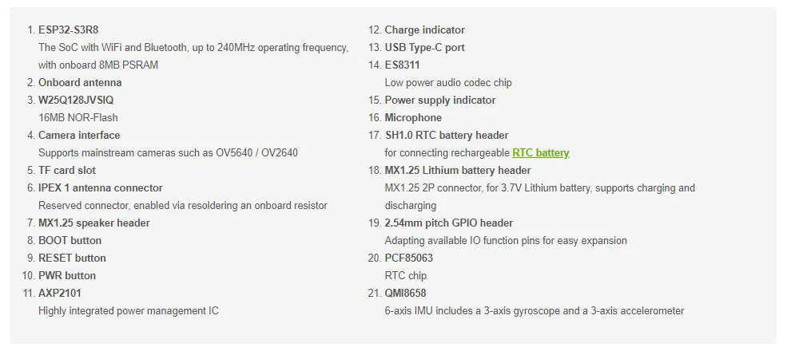

Pin Definition
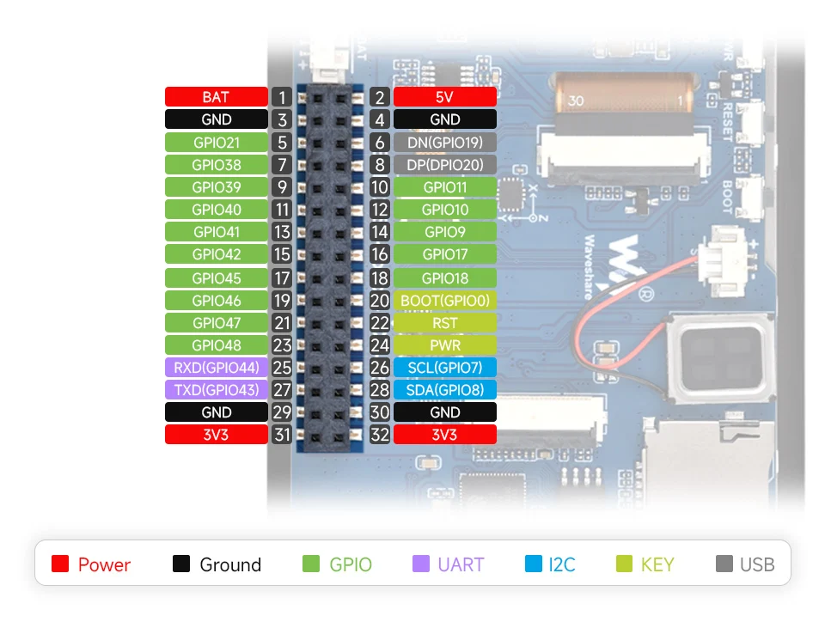

Outline Dimensions
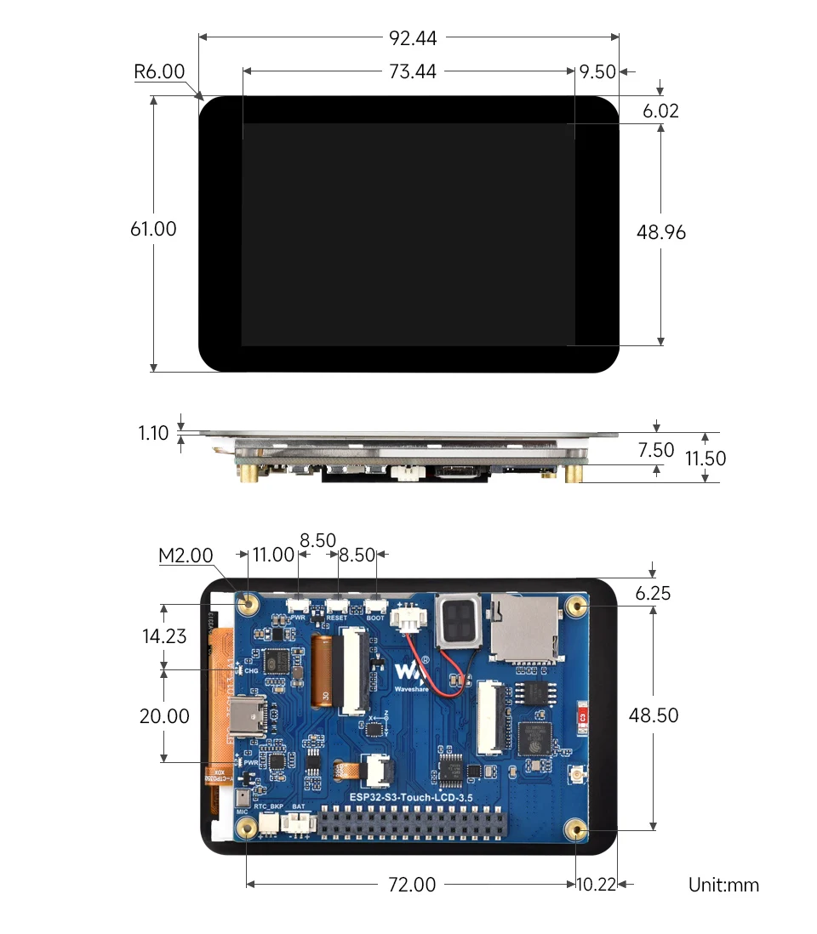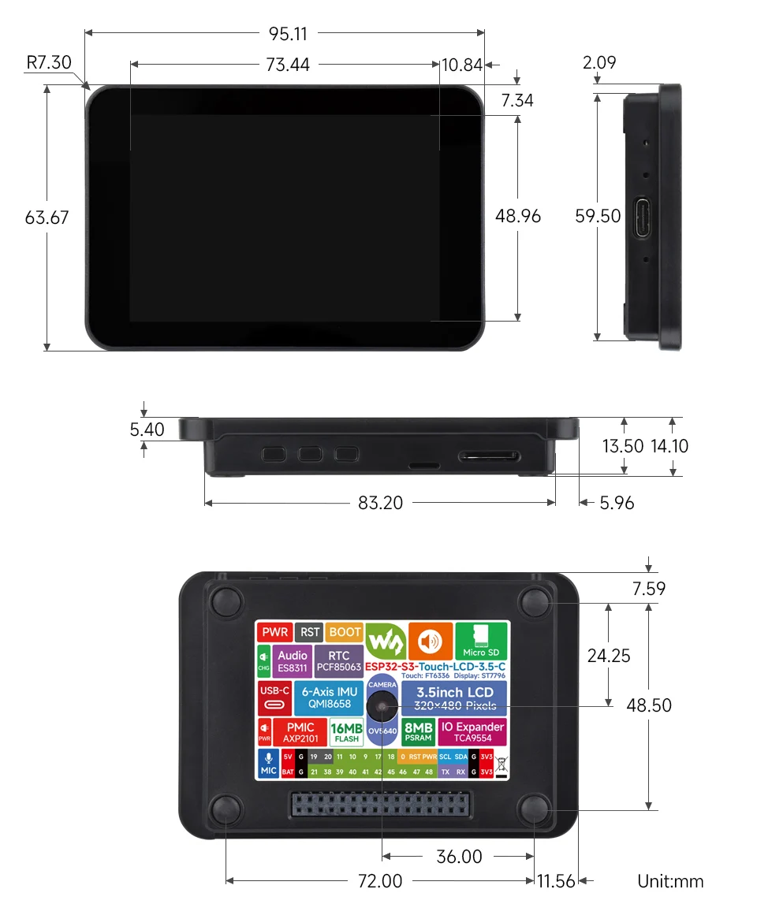
Package Contains

[] ESP32-S3-Touch-LCD-3.5【No Case-Camera】
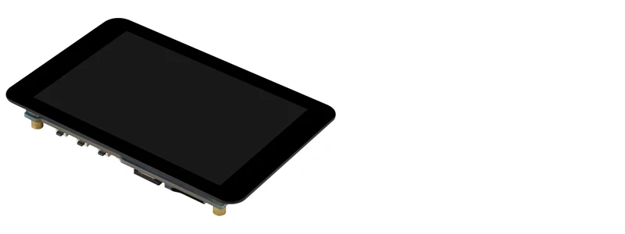
[] ESP32-S3-Touch-LCD-3.5-C【With Case-Camera】

Battery Included: Non105℃挥发物≤: spotpearn
Compatible With: ESP32-S3n
Accessory Type: LCD Screen
Resolution: 320 × 480
Display Type: 3.5inch IPS Capacitive Touchscreen
Waveshare Esp32 S3
Waveshare Esp32 S3 Touch Lcd 3.5
**High-Performance Integration**
The Waveshare ESP32-S3 3.5inch Touch LCD is a powerful development board designed to integrate seamlessly with the ESP32-S3 MCU. This board is not just a simple display; it's a complete package that includes a high-resolution 3.5inch IPS capacitive touchscreen, making it ideal for creating interactive projects. The advanced features like Wi-Fi and Bluetooth connectivity, along with the onboard audio input and output, make it a versatile tool for AI interaction and offline voice control.
**Ease of Use and Compatibility**
The Waveshare 3.5 inch display is a perfect match for developers and hobbyists looking for a reliable and user-friendly solution. The Type-C connector ensures compatibility with a wide range of devices, while the onboard 3.7V MX1.25 Lithium battery recharge/discharge header simplifies battery management. The PCF85063 RTC chip, powered by a main Lithium battery through an AXP2101 chip, guarantees RTC function even during battery replacement. The PWR and BOOT programmable buttons provide easy custom function development, making this board an excellent choice for various projects.nn
**Advanced Features for Innovative Applications**
The Waveshare 3.5 inch display is not just about the screen; it's about the possibilities it opens up. The board is equipped with a 6-axis sensor (3-axis accelerometer and 3-axis gyroscope), which can detect motion gestures and count steps, making it suitable for fitness trackers or sports equipment. The onboard camera interface is compatible with mainstream cameras like OV2640 and OV5640, enabling easy integration with video recording or streaming applications. The AXP2101 IC for efficient power management supports multiple voltage outputs, battery charging, and battery management, ensuring your project remains powered and reliable.

